Tutorial 3 – Requirement Reviews & Inspections
Screenshot Report
Field | Details
Website / Tool | DemoBlaze
URL | https://www.demoblaze.com
Module | Product and Cart
Student Task | Review the requirements of the Product and Cart module and execute the 7 test cases.
Test Cases | Same TC IDs as the test case sheet: TC01 to TC07
Tester Name | [Your Name]
Enrollment No | ENROLLMENT_NO
Execution Date | [DD/MM/YYYY]
Environment | Windows 10/11, Google Chrome (latest), internet connection

Test Case Execution

TC01 – Verify products are displayed
TC ID | TC01
Test Case | Verify products are displayed
Test Data | Category: Phones
Expected Result | Product cards with image, name and price are displayed
Actual Result | Products displayed with image, name and price
Status | PASS
Screenshot | 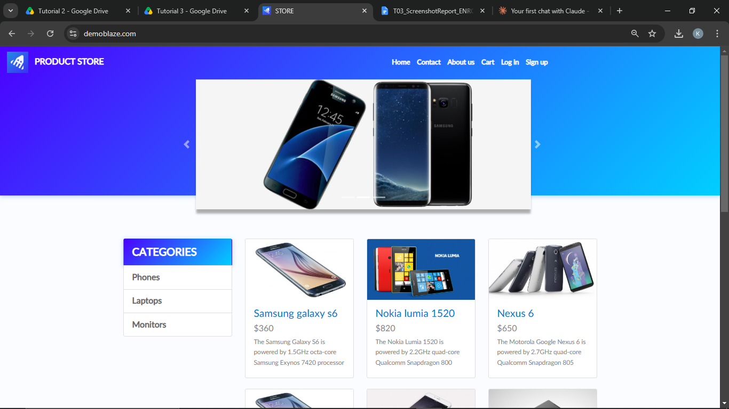

TC02 – Verify a product can be selected
TC ID | TC02
Test Case | Verify a product can be selected
Test Data | Product: Samsung galaxy s6
Expected Result | Product details page opens
Actual Result | Product page opened
Status | PASS
Screenshot | 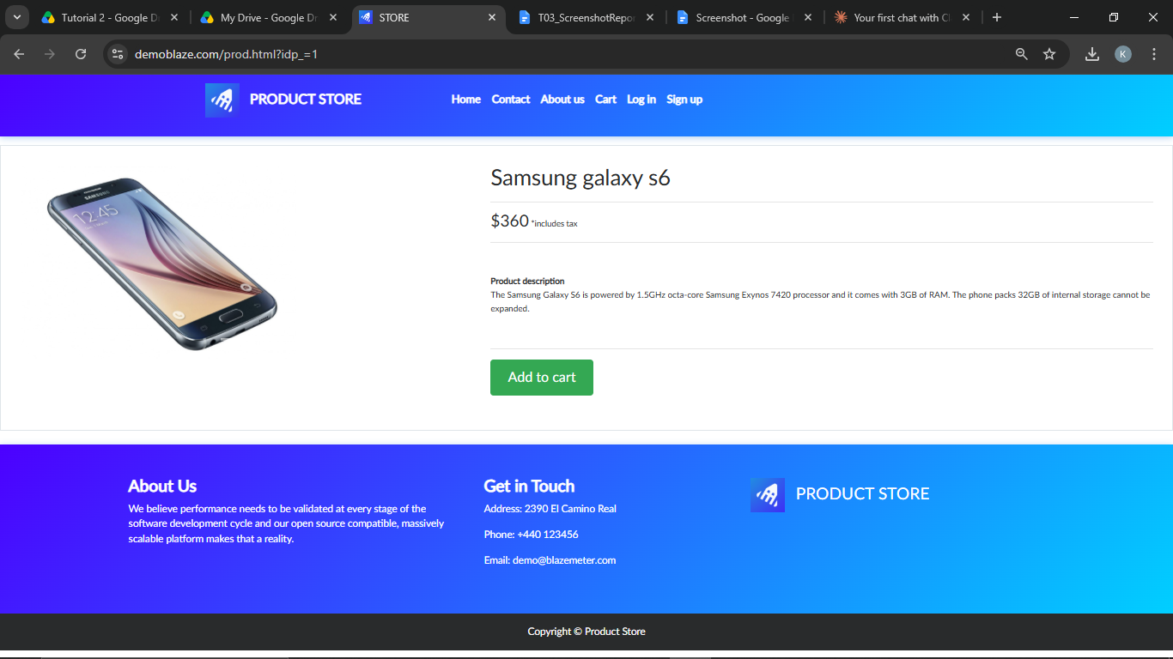
Defect ID | N/A

TC03 – Verify product details are displayed
TC ID | TC03
Test Case | Verify product details are displayed
Test Data | Product: Samsung galaxy s6
Expected Result | Name, price, description and 'Add to cart' button are displayed
Actual Result | Details displayed
Status | PASS
Screenshot
Defect ID | N/A

TC04 – Verify a product can be added to the cart
TC ID | TC04
Test Case | Verify a product can be added to the cart
Test Data | Product: Samsung galaxy s6
Expected Result | Alert 'Product added' is displayed
Actual Result | Alert 'Product added' displayed
Status | PASS
Screenshot | 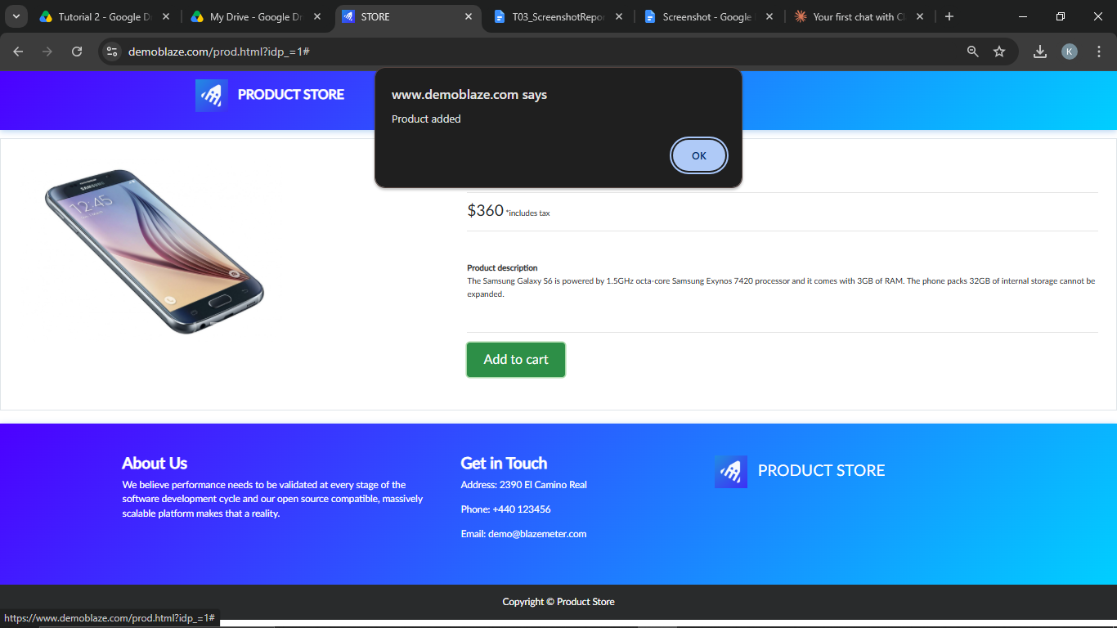
Defect ID | N/A

TC05 – Verify the cart page opens
TC ID | TC05
Test Case | Verify the cart page opens
Test Data | -
Expected Result | Cart page opens with a table of products and a total
Actual Result | Cart page opened
Status | PASS
Screenshot | 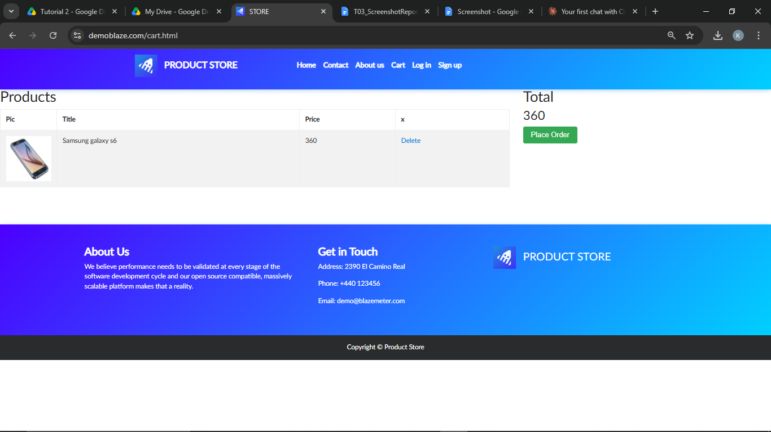
Defect ID | N/A

TC06 – Verify the added product is in the cart
TC ID | TC06
Test Case | Verify the added product is in the cart
Test Data | Product: Samsung galaxy s6
Expected Result | Selected product with its price is listed and total matches
Actual Result | Product and price listed, total matches
Status | PASS
Screenshot | 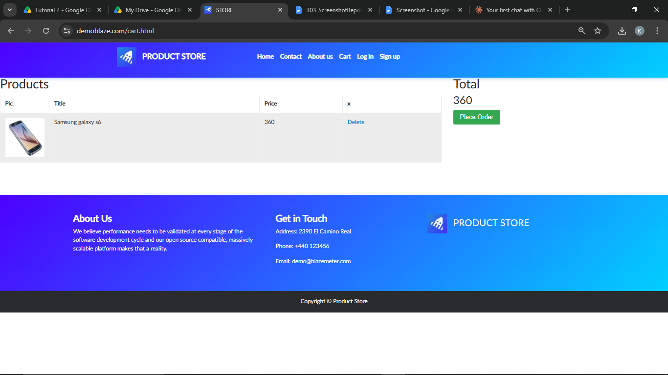
Defect ID | N/A

TC07 – Verify a product can be removed from the cart
TC ID | TC07
Test Case | Verify a product can be removed from the cart
Test Data | Product: Samsung galaxy s6
Expected Result | Product is removed and the cart becomes empty
Actual Result | Product removed
Status | PASS
Screenshot | 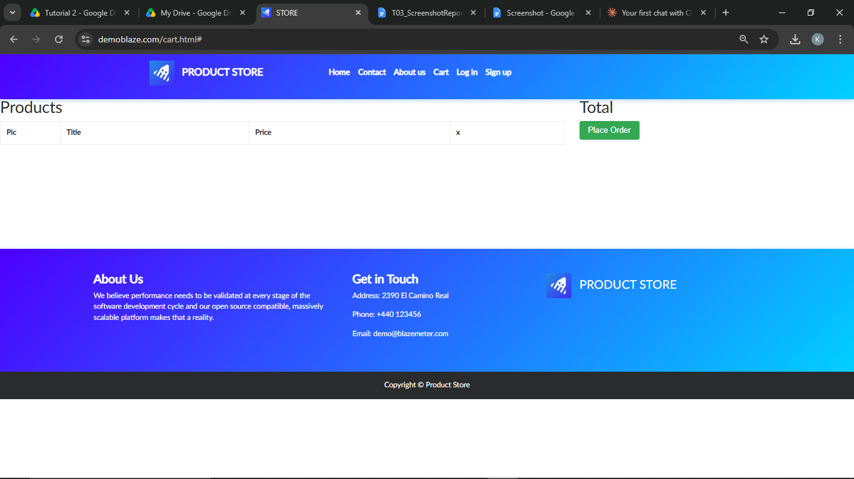
Defect ID | N/A

Requirement Review Table
Requirement | Clear/Unclear | Reason
User can view the list of products | Clear | Testable by observing the product list
User can open a product to see its details | Clear | Testable
User can add a product to the cart | Clear | Testable (alert and cart entry)
User can open the cart and see added products | Clear | Testable
User can remove a product from the cart | Clear | Testable
Website should be fast | Unclear | No response time specified
Product images should load properly | Unclear | No size/format or load-time criteria given
Cart should be easy to use | Unclear | Subjective; no measurable criteria

Test Execution Summary
Metric | Value
Total Test Cases | 7
Passed | 7
Failed | 0
Blocked | 0
Not executed yet (fill after running) | 0
Pass % | 100.0%

